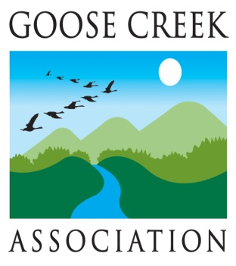

Ms. Holly McChesney
ARCADIS
6041 Wallace Road Extension, Suite 300
Wexford PA 15090

May 20, 2015

Re: Proposed Train Control Towers within Fauquier County

Dear Ms. McChesney:

The Goose Creek Association (GCA) appreciates the opportunity to comment on the above project proposal. Our organization is charged with monitoring stream water quality, proposed developments, legislation, zoning changes, and other actions that have potential impact on the environment and quality of life in the Goose Creek watershed in Fauquier and Loudoun Counties, VA. We are a nonprofit 501C3 organization with hundreds of members who share a determination to protect and preserve the natural resources, historic heritage and rural quality of life found in this beautiful part of Virginia.

GCA is concerned that the proposed eleven 60-foot positive train control towers and their associated development impacts, i.e., grading and clearing, access roads, site structure/s, fencing, and signage will likely have a detrimental impact on the rural and historic nature of the Crooked Run Rural Historic District (CRRHD), the Rectortown Historic District, and the Goose Creek, a State Scenic Waterway.

While we understand that ARCADIS and its client, the Norfolk Southern Railway, have the right of way and may be required to erect these towers for safety purposes, we hope and expect that their construction will respect the pristine Goose Creek and its tributaries, which are part of the Potomac and Chesapeake Bay watersheds that provide drinking water for millions of residents and animals. We also hope and expect that the towers’ construction will respect the historic and pristine landscapes and view sheds of the Cromwell’s Run Rural Historic District and the Crooked Run Valley Rural Historic District, including nearby Marshall, Rectortown (a national and state registered historic district), Delaplane and Markham. Sixty-foot metal towers jutting above the tree line are not consistent with the historic character of this area, so we expect that their positioning will be as unobtrusive as possible.

The “elbow” in this part of the railroad’s Crescent Trail (between Manassas and Linden) was built to accommodate rural commercial and farming interests prior to the Civil War. The railroad does not serve those local interests today. Today the area is largely residential and revered for its historic significance and natural beauty, including the cleanliness of the Goose Creek and its tributaries. In the normal course of its stream monitoring, GCA will report to the appropriate authorities any increased sediment or silting of the creek beds near the railway line before, during and after the proposed construction.

In addition, GCA requests disclosure of any other plans the railroad may have to upgrade or modernize this section of the railroad bed, as well as additional sites under consideration or alternate structures to be built by ARCADIS or its client.

It is not our intention to obstruct or deny required train communications for safety purposes, but, the particular natural and historical attributes, whose importance is recognized by local, state, and federal authorities in this case, require the utmost care and considered evaluation so that the integrity of the area may be protected and preserved for visitors, residents, and future generations to enjoy.

Thank you.

Sincerely yours,

Lori Keenan McGuinness, Co-Chair
Bonnie Mattingly, Co-Chair

cc: Mr. Holder Trumbo, Supervisor, Fauquier County, Scott District
Mr. Peter Schwartz, Supervisor, Fauquier County, Marshall District
State Delegate Michael Webert
State Senator Jill Vogel Holtzman
Mr. Chris Miller, Piedmont Environment Council
The Mosby Heritage Area Association
VA DHR, Chris Novelli

